Question 1
Q. What Is The Context API In React? How Is It Used To Manage Global State Across Multiple Components?
Ans : The Context API Is A Feature In React Used To Share Data (Global State) Between Components Without Passing Props Manually At Every Level.
It Solves The Problem Of “Prop Drilling”, Where Data Has To Be Passed Through Multiple Intermediate Components.
How It Works:
- Create A Context Using createContext().
- Provide The Context Value Using A Provider Component.
- Access The Value In Child Components Using useContext() Or The Context.Consumer.
Use Case:
- Useful For Sharing Data Like Theme, Authentication, User Info, Language, Or App Settings Across Many Components.
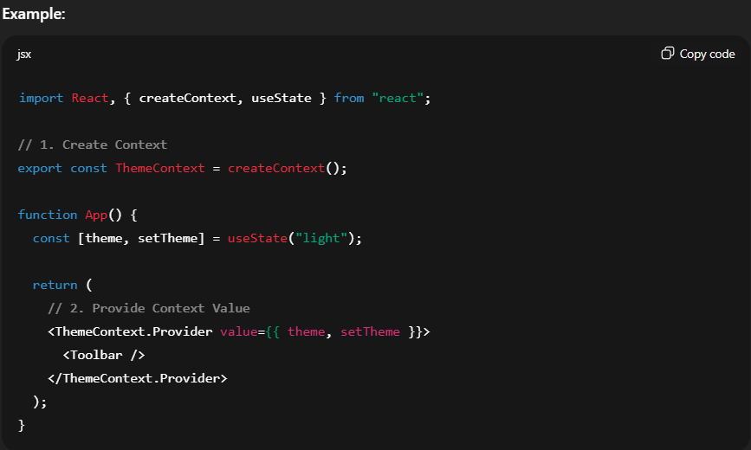
Question 2
Q. Explain How createContext() And useContext() Are Used In React For Sharing State.
Ans :
- createContext():
- Used To Create A New Context Object.
- Returns An Object With Two Components:
  - Provider: Used To Supply The Data.
  - Consumer: (Optional) Used To Access Data In Class Components.
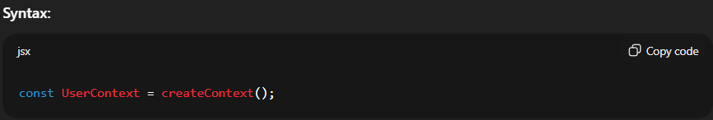
- useContext():
- A Hook That Allows You To Consume Context Values In Functional Components Without Using Consumers.
